To put a picture on the screen of your mobile app, we need to proceed in 3 simple steps:

Level of difficulty:   
Estimated time: 5 mn

* Import your picture . You need to have a very small picture ready to use on your computer.
* Create a Label (see previous lesson: How to add text to your app)
* Delete the text of the Label and put the picture instead.

1. Importing a picture in your mobile app:

[**www.codapps.io**](http://www.codapps.io)by Clement Levallois **@codapps_io** [**www.coursera.org/learn/codapps**](http://www.coursera.org/learn/codapps)



**Module 2: How to add text, pics, links etc. to your app**

*How to add pics to your app*

Double click on theme.res to open a new window. **It can take a while to open it, be patient!**

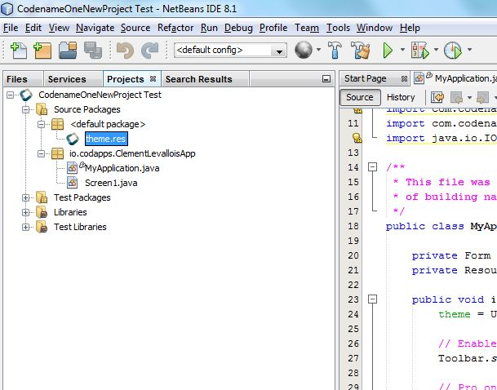

**Double click on this file**

1. In the window that is open, click in the Menu “Images”, choose “Add Images”:

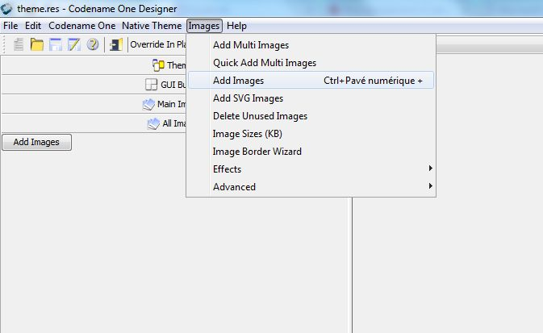

click here

Level of difficulty:   
Estimated time: 5 mn

Please choose a picture which has a small file size, let’s say 50kb max. Why? Of course you can put larger pictures, but in this course we use the free plan of CodenameOne, and this limits the size of the apps we can create. To make sure we stay within the limits of size, small pictures are useful.

1. Save this window (File -> Save) in the menu, and close it (File -> Exit)



**Module 2: How to add text, pics, links etc. to your app**

*How to add pics to your app*

[**www.codapps.io**](http://www.codapps.io)by Clement Levallois **@codapps_io** [**www.coursera.org/learn/codapps**](http://www.coursera.org/learn/codapps)



1. Open the screen of your app, create a Label in it (for this, see the lesson just before. It takes 2 minutes), and select it (it is selected when you see green borders around it). You should get this:

Level of difficulty:   
Estimated time: 5 mn

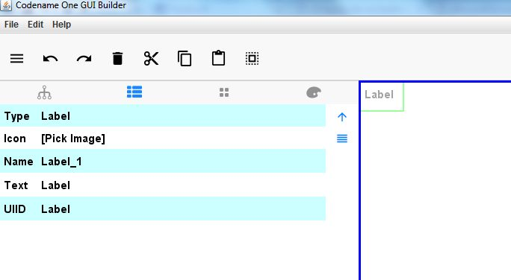



[**www.codapps.io**](http://www.codapps.io)by Clement Levallois **@codapps_io** [**www.coursera.org/learn/codapps**](http://www.coursera.org/learn/codapps)



**Module 2: How to add text, pics, links etc. to your app**

*How to add pics to your app*

1. Delete the text of your Label.

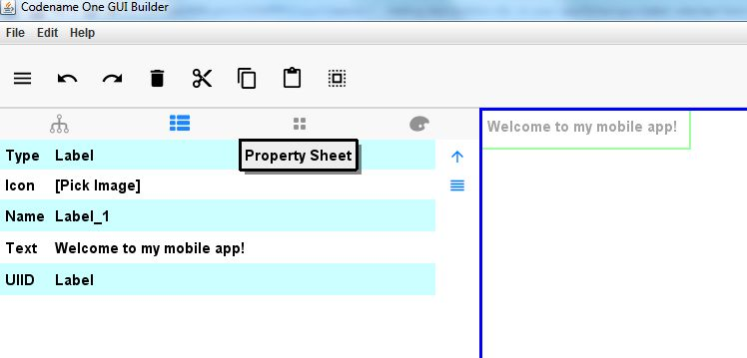

a. Click here

c. This should be empty now

b. Delete the text. Click “Enter” to see the changes

1. Now, click on “Pick Image” and select the image you had imported. Click Enter. The result should look like this:

**Module 2: How to add text, pics, links etc. to your app**

*How to add text to your app*

Level of difficulty:   
Estimated time: 5 mn

[**www.codapps.io**](http://www.codapps.io)by Clement Levallois **@codapps_io** [**www.coursera.org/learn/codapps**](http://www.coursera.org/learn/codapps)



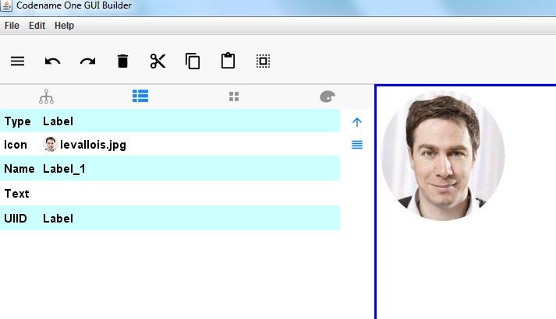

a. Click here to add a pic

In the next module, we will see how we can change the place of the pictures, texts and buttons… on the screen!